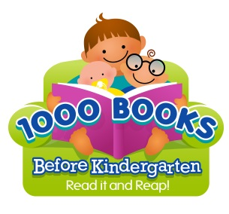
Dear Parents/Caregivers:
On behalf of the BCCLS community, we invite you to participate in this free program which encourages you to read 1,000 books with your child before he or she begins kindergarten.
PROGRAM OVERVIEW
The concept is simple, but the rewards are priceless. Read a book (any book) to your newborn, infant, toddler, and/or preschooler. The goal is to read 1,000 books before your child starts kindergarten (yes, you can repeat books!). Does it sound hard? If you read just one book a night, you will have read 365 books in a year; that is 730 books in two years and 1,095 books in three years. If you consider that most children start kindergarten at around five years of age, you have more time than you think. The key is perseverance. Make it exciting. When your children reach a milestone, give him/her a small reward (stickers, books, etc. ).
HOW TO PARTICIPATE
• Read with your child. Studies have shown that reading with your child provides a great opportunity for bonding.
• Keep track of the titles of any book being read to your child (this includes other family members and teachers) either on the log we have provided or on the 1000 books app (available for iPhone and Android [coming soon]).

FREQUENTLY-ASKED-QUESTIONS
- Who can participate in this program? Any child from birth until he or she enters kindergarten can participate.
- How long will the program take? The program is self-paced and will depend on how often you read together.
- How many of my children can participate? All of them (provided they have not yet started kindergarten). Make it even more fun and read as a family!
- Do we have to read books from the library? No, you can read books from anywhere. Just remember to log them!
- Can I count a book more than once? You can! Record the book as many times as you read it!

FOR MORE INFORMATION
Contact your local library.

